**Configure iSCSI Target (Server) & Initiator (Client) in Linux (RHEL 8)**

[root@localhost ~]# yum install -y targetcli

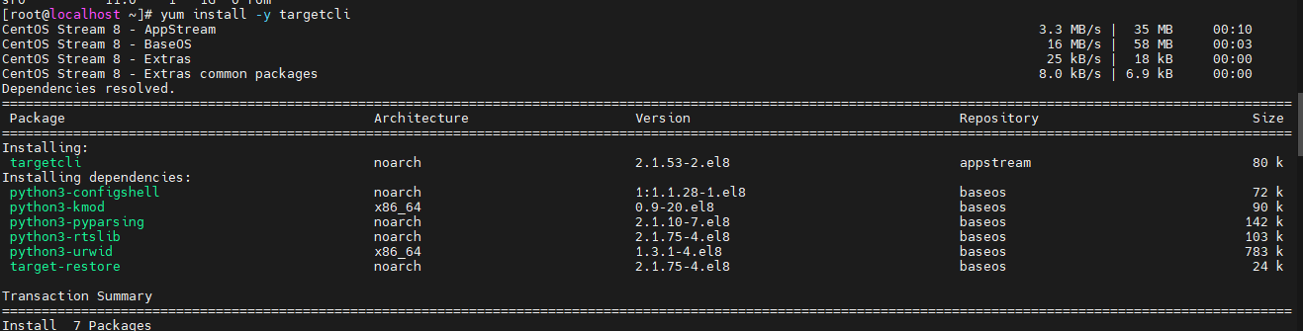

[root@localhost ~]# lsblk

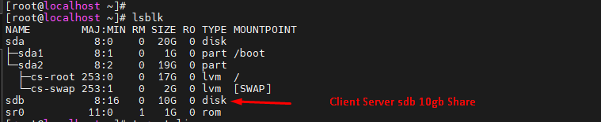

[root@localhost ~]# targetcli

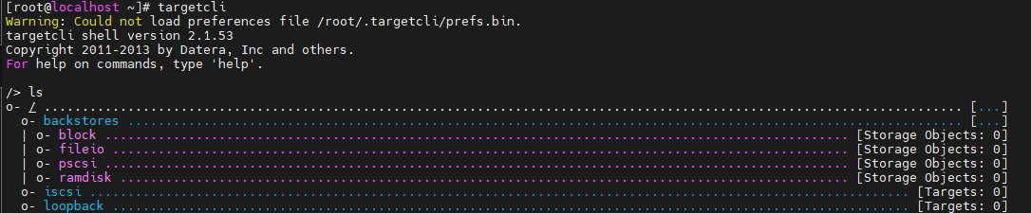

/backstores/block create name /dev/sdb

Example: /> /backstores/block create triangle /dev/sdb

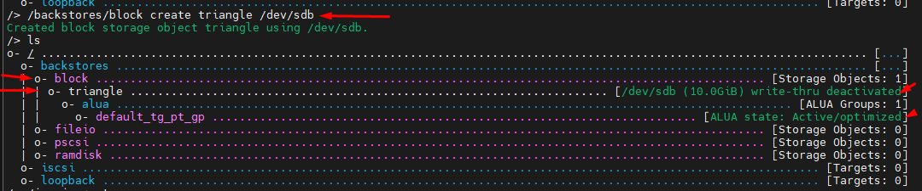

/> /iscsi create

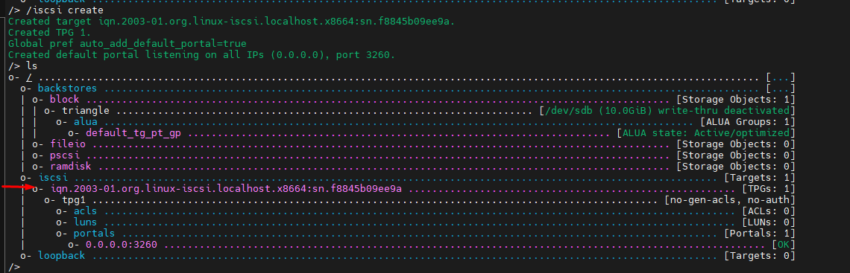

/> /iscsi/iqn.2003-01.org.linux-iscsi.localhost.x8664:sn.f8845b09ee9a/tpg1/luns create /backstores/block/triangle

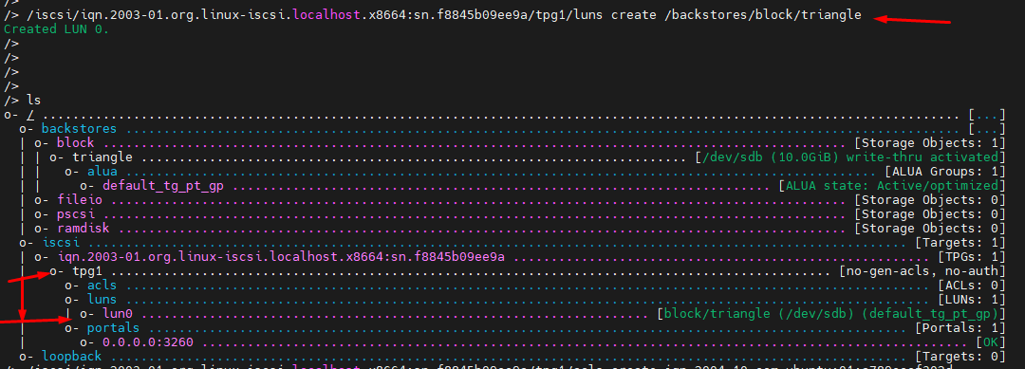

[root@localhost ~]# firewall-cmd --add-port=3260/tcp --permanent

[root@localhost ~]# firewall-cmd --reload

[root@localhost ~]# firewall-cmd --list-all

/> /iscsi/iqn.2003-01.org.linux-iscsi.localhost.x8664:sn.f8845b09ee9a/tpg1/acls create iqn.1994-05.com.redhat:ecdd3bdbcf15 // Rad mark Client iqn

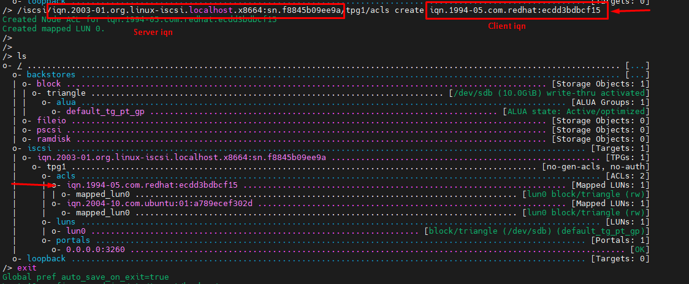

/> saveconfig

=============Client Server

[root@localhost ~]# yum install -y iscsi-initiator-utils

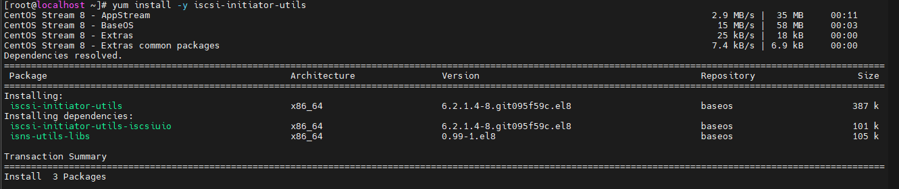

[root@localhost ~]# cat /etc/iscsi/initiatorname.iscsi

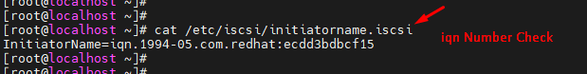

[root@localhost ~]# iscsiadm -m discovery -t sendtargets -p 10.200.6.19 

[root@localhost ~]# iscsiadm -m node -T iqn.2003-01.org.linux-iscsi.localhost.x8664:sn.f8845b09ee9a 10.200.6.19 -l

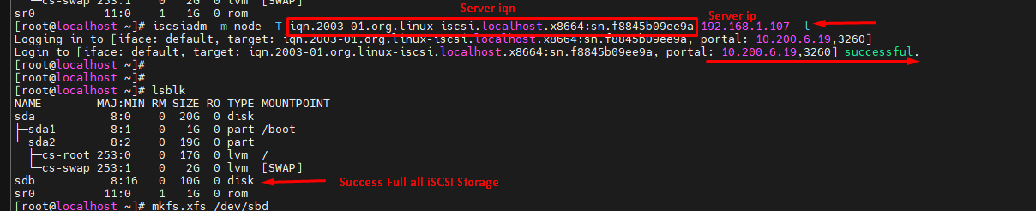

[root@localhost ~]# mkfs.xfs /dev/sdb

[root@localhost ~]# mount /dev/sdb /root/iSCSI/

**//Sorce Link:**

<https://www.youtube.com/watch?v=f6-4xOsxHL8&t=341s>

**Delete acls**

iscsi> cd /iscsi/iqn.2022-03.com.triangle:storage32/tpg1/acls/

/iscsi/iqn.20...e32/tpg1/acls> ls

/iscsi/iqn.20...e32/tpg1/acls> delete iqn.1994-05.com.redhat:48ba96b224